**Job Tracker**

A

Minor Project Report

Submitted in partial fulfillment of the requirement for the award of degree of

**Bachelor of Technology**

In

**Computer Science & Engineering**

Submitted to

**RAJIV GANDHI PROUDYOGIKI VISHWAVIDYALAYA,**

**BHOPAL (M.P.)**



**Guided By Submitted By**

Prof. Virendra Dani Rohan Raikwar (0875CS181122)

Tarun Chandel(0875CS181142)

Vishal Dangi (0875CS181147)

Vishesh Parmar(0875CS181149)

**DEPARTMENT OF COMPUTER SCIENCE & ENGINEERING**

**SHIVAJIRAO KADAM INSTITUTE OF TECHNOLOGY & MANAGEMENT – TECHNICAL CAMPUS, INDORE (M.P.) - 452020**

**2020-2021**

Declaration

I hereby declared that the work, which is being presented in the project entitled **Job Tracker**  partial fulfillment of the requirement for the award of the degree of **Bachelor of Engineering**, submitted in the Department of Computer Science & Engineering at **Shivajirao Kadam Institute of Technology & Management – Technical Campus, Indore** is an authentic record of my own work carried under the supervision of **Mr. Virendra Dani**I have not submitted the matter embodied in this report for award of any other degree.

Rohan Raikwar (0875CS181122)

Tarun Chandel(0875CS181142)

Vishal Dangi (0875CS181147)

Vishesh Parmar(0875CS181149)

Mr. Virendra Dani

Supervisor

Project Approval Form

I hereby recommend that the project < **Job Tracker>** prepared under my supervision by **Rohan Raikwar(0875CS181122), Tarun Chandel(0875CS181142), Vishal Dangi (0875CS181147), Vishesh Parmar(0875CS181149).**

be accepted in partial fulfillment of the requirement for the degree of Bachelor of Engineering in Computer Science & Engineering.

Mr. Virendra Dani

**Supervisor**

Recommendation concurred in 2020-2021

Mr. Virendra Dani

**Project In-charge**

Mr. Virendra Dani

**Project Coordinator**

**Shivajirao Kadam Institute of Technology & Management – Technical Campus**

Department of Computer Science & Engineering



Certificate

The project work entitled **Job Tracker Project** submitted by **Rohan Raikwar(0875CS181122), Tarun Chandel(0875CS181142), Vishal Dangi (0875CS181147), Vishesh Parmar(0875CS181149).** is approved as partial fulfillment for the award of the degree of Bachelor of Engineering in Computer Science & Engineering by Rajiv Gandhi Proudyogiki Vishwavidyalaya, Bhopal (M.P.).

**Internal Examiner External Examiner**

Name:………………. Name: ……………..

Date: …./…/……….. Date: …./…/………..

Acknowledgement

With boundless love and appreciation, we would like to extend our/my heartfelt gratitude and appreciation to the people who helped us/me to bring this work in reality. We would like to have some space of acknowledgement for them.

Foremost, our/I would like to express our sincere gratitude to our supervisor, **Mr. Virendra Dani** whose expertise, consistent guidance, ample time spent and consistent advices that helped us to bring this study into success.

To the project in-charges **Prof._Virendra Dani** for their constructive comments, suggestions, and critiquing even in hardship.

To the honorable **Prof. Prashant Lakkadwala**, Head, Department of Computer Science & Engineering for his favorable responses regarding the study and providing necessary facility.

To the honorable **Dr. Sanjay T. Purkar**, Director, Shivajirao Kadam Institute of Technology & Management – Technical Campus, Indore for his unending support, advises and effort to make possible.

Finally, we would like to pay our thanks to faculty members and staff of Department of Computer Science & Engineering for their timely help and support.

We also like to pay thanks to our **parents** for their eternal love, support and prayers. Without them it is not possible.

Rohan Raikwar (0875CS181122)

Tarun Chandel(0875CS181142)

Vishal Dangi (0875CS181147)

Vishesh Parmar(0875CS181149)

Abstract

Job Tracker project

Finding jobs that best suits the interests and skill set is quite a challenging task for the job seekers. The difficulties arise from not having proper knowledge on the organization’s objective, their work culture and current job openings. In addition, finding the right candidate with desired qualifications to fill their current job openings is an important task for the recruiters of any organization. Online Job Search Portals have certainly made job seeking convenient on both sides. Job Portal is the solution where recruiter as well as the job seeker meet aiming at fulfilling their individual requirement. They are the cheapest as well as the fastest source of communication reaching wide range of audience on just a single click irrespective of their geographical distance. The web application “Job Search Portal” provides an easy and convenient search application for the job seekers to find their desired jobs and for the recruiters to find the right candidate. Job seekers from any background can search for the current job openings. Job seekers can register with the application and update their details and skill set. They can search for available jobs and apply to their desired positions. Android, being open source has already made its mark in the mobile application development. To make things handy, the user functionalities are developed as an Android application. Employer can register with the application and posts their current openings. They can view the Job applicants and can screen them according to the best fit. Users can provide a review about an organization and share their interview experience, which can be viewed by the Employers.

Table of Content

Chapter 1: Introduction

1.1 Rationale

1.2 Goal

1.3 Objective

1.4 Methodology

1.5 Role

1.6 Contribution of Project

1.6.1 Market Potential:

1.6.2 Innovativeness

1.6.3 Usefulness

1.7 Report Organisation

Chapter 2:Requirement Engineering

2.1 Requirement Collection

2.1.1 Functional Requirements

2.1.2 Non-Functional Requirements

Chapter 3:Analysis and Design

3.1 Use-case Diagrams

3.2 ActivityDiagrams

3.3 System Architecture

3.4 Sequence Diagram

3.5 Class Diagram

3.6 E-R Diagram

3.7 Database Design

3.7.1 Schema Definitions

3.7.2 Integrity Contraints

Chapter 4:Construction

4.1 Implementation

4.1.1 Implemented Classes

4.1.2 Implemented Functions

4.1.3 Logical Structure of Data…………………………………………………………………

4.2 Validation

4.3 Testing

4.3.1 White Box Testing

4.3.2 Black Box Testing

Conclusion & Future Works……………………………………………………………………………...

Appendix A (Snapshot)…………………………………………………………………………………..

References………………………………………………………………………………………………...

Chapter 1 – Introduction

1.1 Rationale

The purpose of developing an Online Job Search Portal comes from my idea to make the job search efficient and handy. It helps the recruiters as a primary source of talent search. It also helps the job seekers to search for current vacancies at a single point. Therefore, we can say that Online Job Search Portal act as a bridge of communication between organizations and applicants. With the evolution of technology and internet being the main source of information for the applicants, these job portals and have become an excellent method to reach wide range of audience. Initially, when I am unaware of these portals, I used to do research about companies and their technology stack through their respective websites and apply if the job responsibilities matches my interests. This requires lots of effort and time. However, later when I realized the importance of job search portals, I am able to access jobs in companies, locations that I might not otherwise have learned.

1.2 Goal

This system can be used as an Online Job Portal for the Placements providing to the un employees who are seeking for a job placement. Job Seeker logging into the system and he can should be able to upload their information in the form of a CV. Visitors/Company representatives logging in may also access/search any information put up by Job Seeker. This project is aimed at developing an online search Portal for the Placement Details for job seekers. The system is an online application that can be accessed throughout the organization and outside as well with proper login provided. This system can be used as an Online Job Portal for job seekers, Job Seekers logging should be able to upload their information in the form of a CV. Visitors/Company representatives logging in may also access/search any information put up by Job aspirants.

1.3 Objective

The objective of the web as well as android application is to provide flexibility to the jobseekers by providing the functionalities of both job search and job application in a single application. In addition, this application provides an effective means for the employers to post job vacancies and view the job applications by the interested applicants in a single application. Employers can also view the reviews provided by the jobseekers.

1.4 Methodology

The model that is basically being followed is the AGILE MODEL, which states that the phases are organized in a linear order. First of all the feasibility study is done. Once that part is over the requirement analysis and project planning begins. If system exists one and modification and addition of new module is needed, analysis of present system can be used as basic model. The design starts after the requirement analysis is complete and the coding begins after the design is complete. Once the programming is completed, the testing is done. In this model the sequence of activities performed in a software development project are: -

• Requirement Analysis

• Project Planning

• System design

• Detail design

• Coding

• Unit testing

• System integration & testing

Here the linear ordering of these activities is critical. End of the phase and the output of one phase is the input of other phase. The output of each phase is to be consistent with the overall requirement of the system. Some of the qualities of spiral model are also incorporated like after the people concerned with the project review completion of each of the phase the work done.

1.5 Role

Job Tracker is a web application, which serves jobseekers to find available job vacancies and Employers to identify eligible job seekers with the prospect of selecting the most qualified candidates. The only way to select best-qualified candidate is to have a pool of eligible applicants, which is possible by drawing the interest of individuals in the market. Job search portals best serve this purpose. E-recruitment has become the standard means for employers and job seekers to meet their respective objectives. The traditional methods for recruitment includes Job fairs, University career employment services, Employee referrals, advertising in the newspapers, televisions etc. With the advancement in technology and growth of internet usage, the e-recruitment has revolutionized the way organizations hire and candidates search for jobs. With the Online Job search portals, the recruitment process is speeded up at every stage from job postings, to receiving applications from candidates, interviewing process.

1.6 Contribution of project

Job tracker stands as a revolutionizing element in the sphere of recruitment. They act as a communication bridge between applicants and recruiters facilitating their requirements. This application helps organizations to have a greater exposure to the candidate pool and also job seekers facilitating wide search of jobs matching their interests. The web application provides flexibility to the jobseekers to view the openings and applied jobs without the need to carry a laptop. This application provides an enhanced user experience for both employer and jobseeker. It provides user friendly interface which facilitates in reaching wide range of audience I have gained a very good experience working with various technologies at every phase. Development of this project boosted my confidence and web development. This requires lots of effort and time. However, later when I realized the importance of job search portals, I am able to access jobs in companies, locations that I might not otherwise have learned. The cost of searching/posting jobs will be much less compared to the traditional way of advertising. Job search portal stands as an effective means for Employers to outline the job vacancies, responsibilities and qualifications to attract jobseekers

Chapter 2 – Requirement Engineering

**2.1.1 Functional Requirement**

1. **Student Login**: To make sure that only valid registered students have access to the website. Encryption and Decryption are used to ensure security. Client side and server side validations are being performed.
2. **Forgot Password**: To help students in case they forget their username Or password. Students are required to provide their mail id ,date of birth as well as registered mobile number. If all the credentials are valid then the students is provided with a link to update his/her password.
3. **Update Resume**: This provides students the facility to upload and update their resume. The student must be upload resume in pdf format. Necessary instructions are provides in the help section of the website. The application gives an error and notifies that the format is different from the given format.
4. **Register**: Students may register for a company visiting the campus on a specified date. Specific time duration is provided and students need to register in that given time frame. Otherwise he is not eligible to sit for that particular company.
5. **View Company Profile**: This functionality provides the students facility to have a look at various profiles for which company is hiring. This makes sure that student knows beforehand the requirements of the company and can prepare himself to face the interview.
6. **View Company Details**: Students get to know company related information like domain, eligibility criteria, policies etc. Based on the information a student can decide if he/she wants to register for the given company.
7. **Contact Placement Cell**: Students can shoot an email to placement cell representative in case they face a problem. If students have queries and suggestions during placement process they can get in touch with the placement cell easily.
8. **Download Material**: Students can download previous years papers and materials to prepare for placement. Focus is on providing latest technical and aptitude questions for placement. Focus is on providing latest technical and aptitude questions to keep students up to date with the latest placement procedures.
9. **Admin Login**: To make sure that only valid administrators can login with administrator rights.
10. **Add Events**: This is to facilitate administrators to post notification and add an event when company is about to visit the campus so that students can register for the company.
11. **Approve Students**: This is to make sure that only students who have registered and satisfy eligibility criteria can sit for placement.
12. **Past Recruiters**: Recruiters get know about the companies that are regular recruiters or the companies that have visited the campus in the past.

**2.1.2 Non Functional Requirement**

1. **Supportability**: The application works fine on a wide range hardware platforms with proper internet connectivity and a popular internet browser. The applications is cross-platforms and responsive.
2. **Response Time**: The application is quite efficient when used with minimum specified hardware and software requirements. However higher the configuration, better the performance.
3. **Security and Privacy**: The application is built using J2EE. Thus application is secured as all the properties of java are inherited.
4. **Error Handling**: The system shall alert the users of errors consistent with java error handling. Backup of database can be taken to ensure application is in a stable state case of malfunctionality**.**

**Chapter 3 – Analysis and Design**

**3.1 Use-case Diagram**

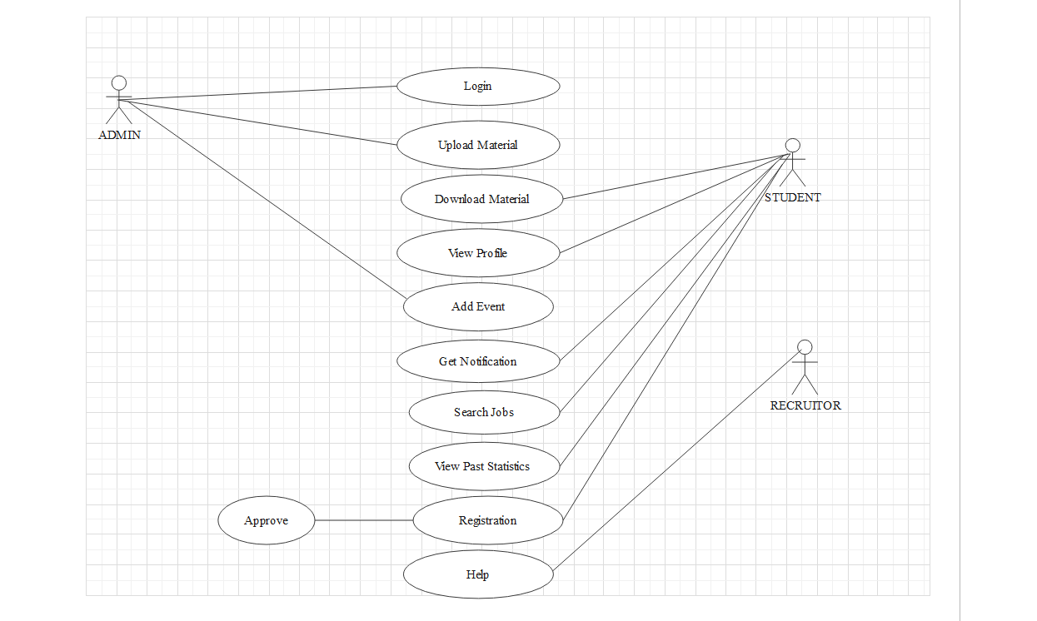

**3.2 Activity Diagam**

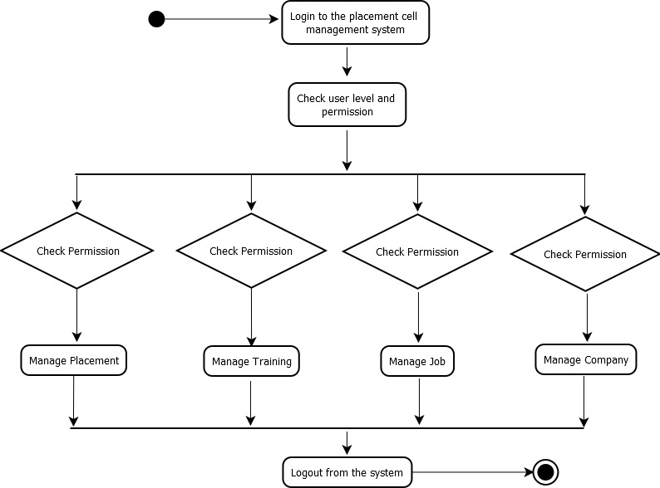

**3.3 System Architecture**

**3.4 Sequence Diagram**

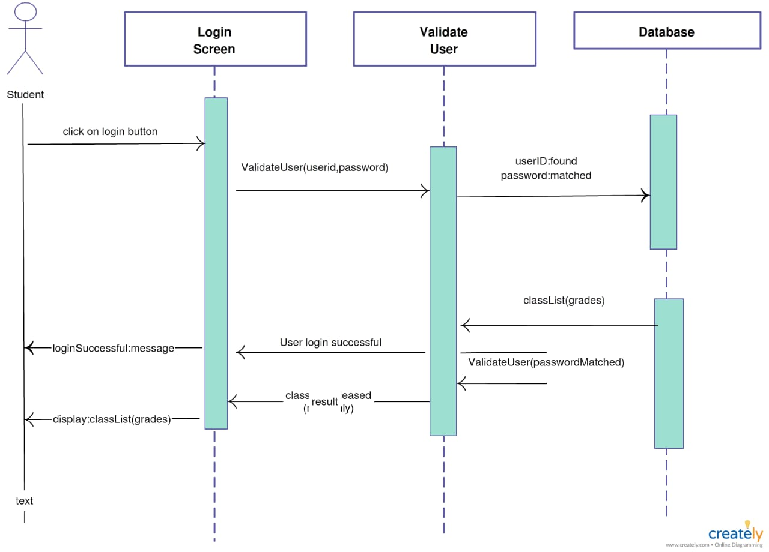

**3.5 Class Diagram**

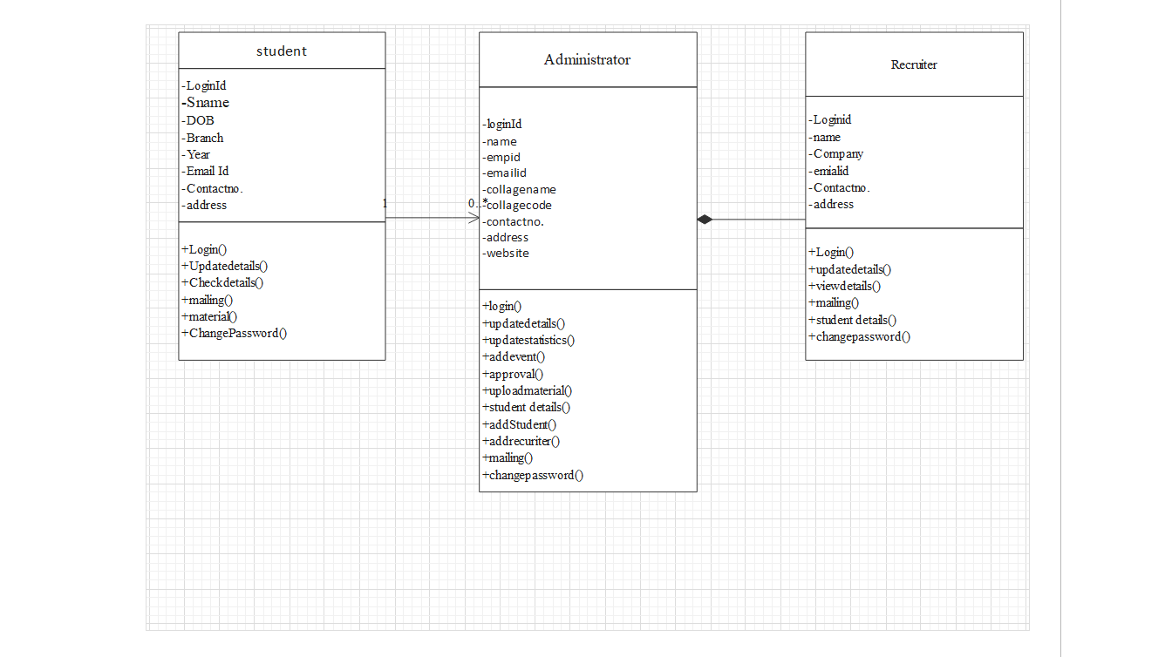

**3.6 E-R Diagram**

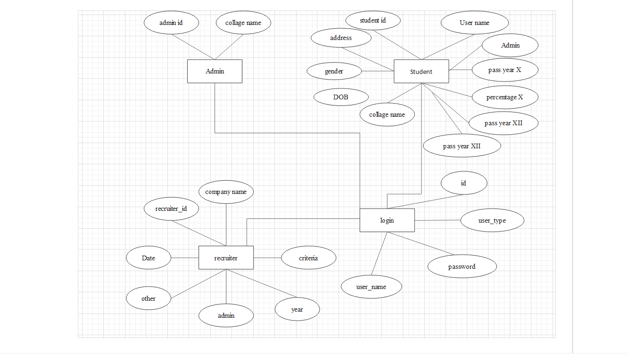

**3.7 Database dasign**

